Create table LMS_MEMBERS

(MEMBER_ID Varchar(10),

MEMBER_NAME Varchar(30) NOT NULL,

CITY Varchar(20),

DATE_REGISTER Date NOT NULL,

DATE_EXPIRE Date ,

MEMBERSHIP_STATUS Varchar(15)NOT NULL,

Constraint LMS_cts1 PRIMARY KEY(MEMBER_ID));

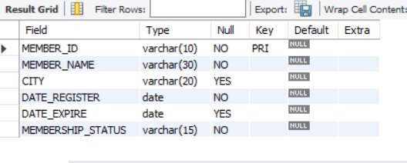

Create table LMS_SUPPLIERS_DETAILS

(SUPPLIER_ID Varchar(3),

SUPPLIER_NAME Varchar(30) NOT NULL,

ADDRESS Varchar(50),

CONTACT bigint(10) NOT NULL,

EMAIL Varchar(15) NOT NULL,

Constraint LMS_cts2 PRIMARY KEY(SUPPLIER_ID));

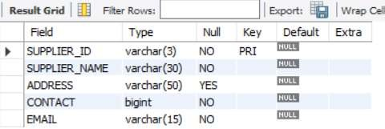

Create table LMS_FINE_DETAILS

(FINE_RANGE Varchar(3),

FINE_AMOUNT decimal(10,2) NOT NULL,

Constraint LMS_cts3 PRIMARY KEY(FINE_RANGE));

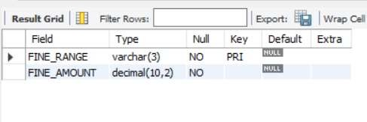

Create table LMS_BOOK_DETAILS

(BOOK_CODE Varchar(10),

BOOK_TITLE Varchar(50) NOT NULL,

CATEGORY Varchar(15) NOT NULL,

AUTHOR Varchar(30) NOT NULL,

PUBLICATION Varchar(30),

PUBLISH_DATE Date,

BOOK_EDITION int(2),

PRICE decimal(8,2) NOT NULL,

RACK_NUM Varchar(3),

DATE_ARRIVAL Date NOT NULL,

SUPPLIER_ID Varchar(3) NOT NULL,

Constraint LMS_cts4 PRIMARY KEY(BOOK_CODE),

Constraint LMS_cts41 FOREIGN KEY(SUPPLIER_ID) References LMS_SUPPLIERS_DETAILS(SUPPLIER_ID));

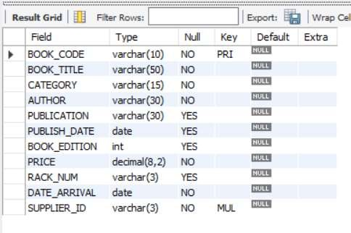

Create table LMS_BOOK_ISSUE

(BOOK_ISSUE_NO int,

MEMBER_ID Varchar(10) NOT NULL,

BOOK_CODE Varchar(10) NOT NULL,

DATE_ISSUE Date NOT NULL,

DATE_RETURN Date NOT NULL,

DATE_RETURNED Date NULL,

FINE_RANGE Varchar(3),

Constraint LMS_cts5 PRIMARY KEY(BOOK_ISSUE_NO),

Constraint LMS_Mem FOREIGN KEY(MEMBER_ID) References LMS_MEMBERS(MEMBER_ID),

Constraint LMS_BookDetail FOREIGN KEY(BOOK_CODE) References LMS_BOOK_DETAILS(BOOK_CODE),

Constraint LMS_FineDetail FOREIGN KEY(FINE_RANGE) References LMS_FINE_DETAILS(FINE_RANGE));

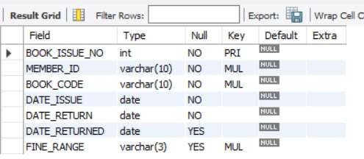

Insert into LMS_MEMBERS Values('LM001', 'AMIT', 'CHENNAI', '2012-02-12', '2013-02-

11','Temporary'),

('LM002', 'ABDHUL', 'DELHI', '2012-04-10', '2013-04-09','Temporary'),

('LM003', 'GAYAN', 'CHENNAI', '2012-05-13','2013-05-12', 'Permanent'),

('LM004', 'RADHA', 'CHENNAI', '2012-04-22', '2013-04-21', 'Temporary'),

('LM005', 'GURU', 'BANGALORE', '2012-03-30', '2013-05-16','Temporary'),

('LM006', 'MOHAN', 'CHENNAI', '2012-04-12', '2013-05-16','Temporary');

select * from lms_members;

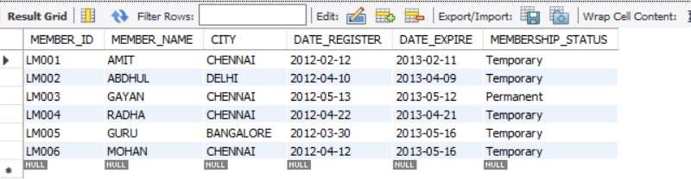

Insert into LMS_SUPPLIERS_DETAILS Values

('S01','SINGAPORE SHOPPEE', 'CHENNAI', 9894123555,'sing@gmail.com'),

('S02','JK Stores', 'MUMBAI', 9940123450 ,'jks@yahoo.com'),

('S03','ROSE BOOK STORE', 'TRIVANDRUM', 9444411222,'rose@gail.com'), ('S04','KAVARI STORE', 'DELHI', 8630001452,'kavi@redif.com'), ('S05','EINSTEN BOOK GALLARY', 'US', 9542000001,'eingal@aol.com'), ('S06','AKBAR STORE', 'MUMBAI',7855623100 ,'akbakst@aol.com');

select * from LMS_SUPPLIERS_DETAILS;

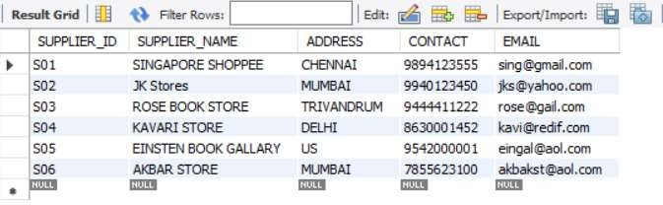

Insert into LMS_FINE_DETAILS Values

('R0', 0),

('R1', 20),

('R2', 50),

('R3', 75),

('R4', 100),

('R5', 150),

('R6', 200);

select * from LMS_FINE_DETAILS;

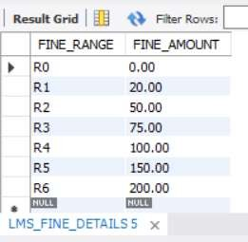

Insert into LMS_BOOK_DETAILS VALUES

('BL000010', 'Java ForvDummies', 'JAVA', 'Paul J. Deitel', 'Prentice Hall', '1999-12-10', 6, 575.00, 'A1', '2011-05-10', 'S01'),

('BL000002', 'Java: The Complete Reference ', 'JAVA', 'Herbert Schildt', 'Tata Mcgraw Hill ', '2011-10- 10', 5, 750.00, 'A1', '2011-05-10', 'S03'),

('BL000003', 'Java How To Do Program', 'JAVA', 'Paul J. Deitel', 'Prentice Hall', '1999-05-10', 6, 600.00, 'A1', '2012-05-10', 'S01'),

('BL000004', 'Java: The Complete Reference ', 'JAVA', 'Herbert Schildt', 'Tata Mcgraw Hill ', '2011-10- 10', 5, 750.00, 'A1', '2012-05-11', 'S01'),

('BL000005', 'Java How To Do Program', 'JAVA', 'Paul J. Deitel', 'Prentice Hall', '1999-12-10', 6, 600.00, 'A1', '2012-05-11', 'S01'),

('BL000006', 'Java: The Complete Reference ', 'JAVA', 'Herbert Schildt', 'Tata Mcgraw Hill ', '2011-10- 10', 5, 750.00, 'A1', '2012-05-12', 'S03'),

('BL000007', 'Let Us C', 'C', 'Yashavant Kanetkar ', 'BPB Publications', '2010-12-11', 9, 500.00 , 'A3', '2010-11-03', 'S03'),

('BL000008', 'Let Us C', 'C', 'Yashavant Kanetkar ','BPB Publications', '2010-05-12', 9, 500.00 , 'A3', '2011-08-09', 'S04'),

('BL000009', 'Let Us C#', 'C', 'Yashavant Kanetkar ','BPB Publications', '2010-05-12', 9, 550.00 , 'A3', '2011-08-09', 'S04'),

('BL000011', 'Let Us C++', 'C', 'Yashavant Kanetkar ','BPB Publications', '2010-05-12', 9, 650.00 , 'A3', '2011-08-09', 'S04');

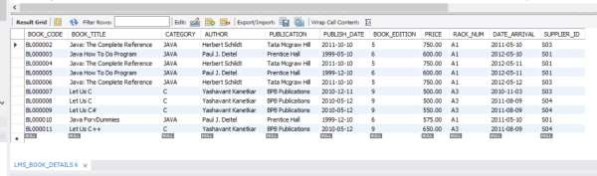select * from LMS_BOOK_DETAILS;

Insert into LMS_BOOK_ISSUE VALUES

(001, 'LM001', 'BL000010', '2012-05-01', '2012-05-16', '2012-05-16', 'R0'),

(002, 'LM002', 'BL000002', '2012-05-01', '2012-05-06','2012-05-16',

(003, 'LM003', 'BL000007', '2012-04-01', '2012-04-16', '2012-04-20','R1'),

(004, 'LM004', 'BL000005', '2012-04-01', '2012-04-16','2012-04-20', 'R1'),

(005, 'LM005', 'BL000008', '2012-03-30', '2012-04-15','2012-04-20' , 'R1'),

(006, 'LM005', 'BL000008', '2012-04-20', '2012-05-05','2012-05-05' , 'R0'),

(007, 'LM003', 'BL000007', '2012-04-22', '2012-05-07','2012-05-25' , 'R4');

select * from LMS_BOOK_ISSUE ;

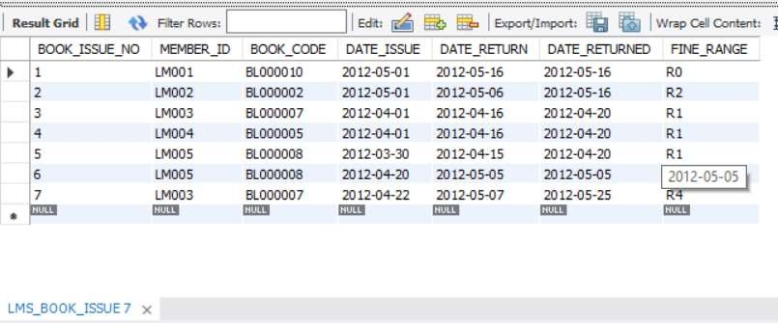

-- 1. Display records of members whose city is Chennai Select * from LMS_MEMBERS where city = "CHENNAI";

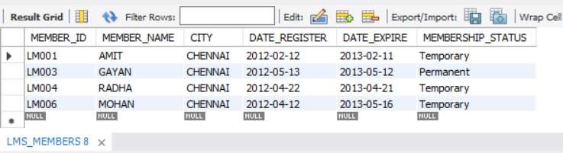

-- 2. Display Records of supplier whose ADDRESS is delhi

select * from LMS_SUPPLIERS_DETAILS where ADDRESS= "delhi";

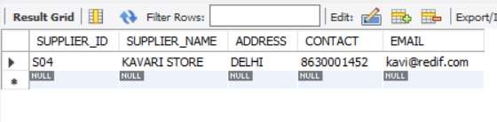

-- 3.show the records of suppliers whose SUPPLIER_ID is 's05' or whos address is 'us' select * from LMS_SUPPLIERS_DETAILS where SUPPLIER_ID= 's05' or ADDRESS= "US";

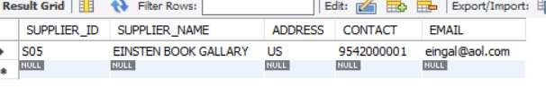

-- 4. change the table name to LMS_SUPPLIERSD

alter table LMS_SUPPLIERS_DETAILS rename LMS_SUPPLIERSD;

select * from LMS_SUPPLIERSD;

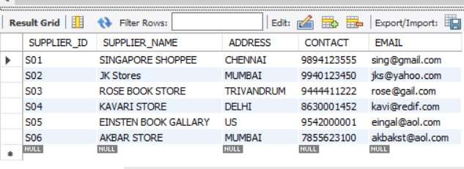

-- 5 display only unique records

select distinct(Author) from LMS_BOOK_DETAILS ;

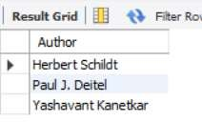

-- 6. display only unique records

select distinct (supplier_name )from LMS_SUPPLIERSD;

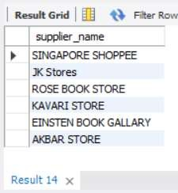

-- 7. display only unique records

select distinct (member_name) from LMS_MEMBERS;

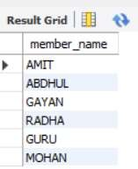

-- 8. show the count of unique departments

select count(distinct(BOOK_CODE))from LMS_BOOK_ISSUE;

- Ans 5

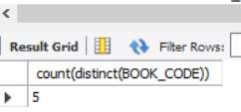

-- 9. show the MEMBER_NAME whosefirst name starts with R select * from LMS_MEMBERS where Member_name like "R%";

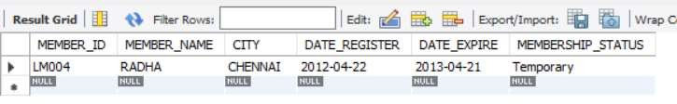

-- 10. show the DATE_REGISTER in the form of dd mmm yy

select day(DATE_REGISTER),month(DATE_REGISTER),year(DATE_REGISTER) from LMS_MEMBERS;

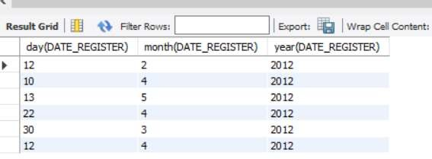

-- 11. show the PUBLISH_DATE in the form of dd mmm yy

select day(PUBLISH_DATE),month(PUBLISH_DATE),year(PUBLISH_DATE) from LMS_BOOK_DETAILS;

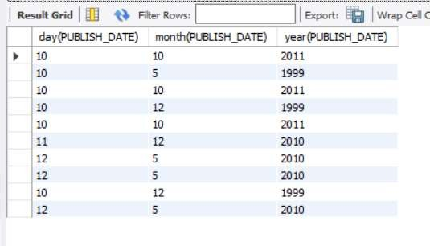

-- 12.-- show the Supplier_name and ADDRESS in capital letters

select upper(SUPPLIER_NAME), upper(ADDRESS) from LMS_SUPPLIERSD;

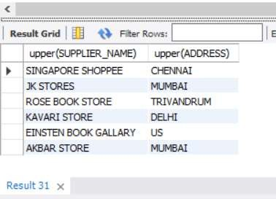

-- 13. show the min FINEAMOUNT. select max(FINE_AMOUNT)

from LMS_FINE_DETAILS ;

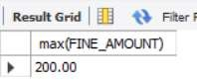

-- 14. select only 7 charchters of 'Yashavant Kanetkar' from AUTHOR from right side. select 'Yashavant Kanetkar', right('Yashavant Kanetkar',7) from LMS_BOOK_DETAILS;

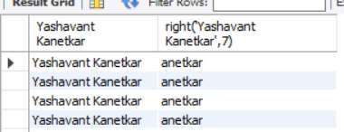

-- 15 . select only ,9 charachters of'SINGAPORE SHOPPEE' from LMS_SUPPLIERS_DETAILS from left side.

select 'SINGAPORE SHOPPEE', left('SINGAPORE SHOPPEE',9) from LMS_SUPPLIERSD;

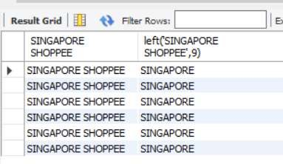

-- 16. replace member names with initials.

select replace (MEMBER_NAME, MEMBER_NAME, concat("Mr.",MEMBER_NAME)) from LMS_MEMBERS;

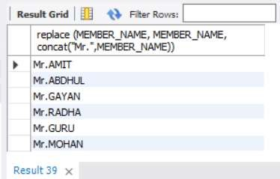

-- 17. Write a query to extract the word from the 10th position of the string select substring('SINGAPORE SHOPPEE',9);

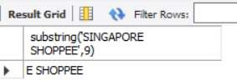

-- 18. Get return date of books from LMS_BOOK_ISSUE table whose RETURNDATE between 16-05- 2012/25-05-2012

select * from LMS_BOOK_ISSUE where DATE_RETURNED between "2012-05-16" and "2012-05-25";

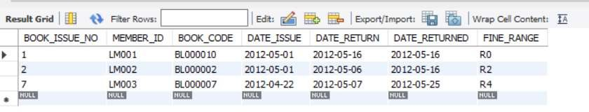

-- 19 Get ARRIVAL date of books from LMS_BOOK_DETAILES table between '2011-05-10'/'2010-11- 03';

select * from LMS_BOOK_DETAILS where PUBLISH_DATE between '1999-12-10' and '2010-05-12';

